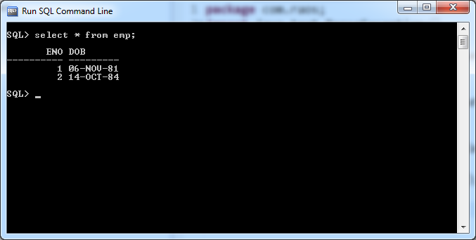

1.Write a application to calculate the age of employee.

**Way1: Age is calculated by Java application.**

**import** java.sql.Connection;

**import** java.sql.DriverManager;

**import** java.sql.PreparedStatement;

**import** java.sql.ResultSet;

**import** java.sql.SQLException;

**public** **class** Sample {

**public** **static** **void** main(String[] args){

**try**(

Connection con=DriverManager.*getConnection*("jdbc:oracle:thin:@localhost:1521:xe","sukumar","sukumar");

PreparedStatement ps=con.prepareStatement("select * from emp");

ResultSet rs=ps.executeQuery() )

{

**if**(rs!=**null**) {

**while**(rs.next()) {

java.sql.Date jsd=rs.getDate(2);

java.util.Date jud=**new** java.util.Date();

**long** ms=jud.getTime()-jsd.getTime();

**float** age=(ms/1000.0f)/60.0f/60.0f/24.0f/365.0f;

System.***out***.println(rs.getInt(1)+" "+age);

}

}

}

**catch**(SQLException e)

{

System.***out***.println(e.getMessage());

}

}//main

}//class

Output:-

1 41.565273

2 38.625546

Way2:- Age is calculated By underlying DB software.

**import** java.sql.Connection;

**import** java.sql.DriverManager;

**import** java.sql.PreparedStatement;

**import** java.sql.ResultSet;

**import** java.sql.SQLException;

**public** **class** Sample {

**public** **static** **void** main(String[] args){

**try**(

Connection con=DriverManager.*getConnection*("jdbc:oracle:thin:@localhost:1521:xe","sukumar","sukumar");

PreparedStatement ps=con.prepareStatement("select eno,(sysdate-dob)/365.25 from emp");

ResultSet rs=ps.executeQuery() )

{

**if**(rs!=**null**) {

**while**(rs.next()) {

System.***out***.println(rs.getInt(1)+" "+rs.getFloat(2));

}

}

}

**catch**(SQLException e)

{

System.***out***.println(e.getMessage());

}

}//main

}//class

Output:-

1 41.53684

2 38.599125